**24.2.1**

Can you hear the news?

No, I didn’t. What is it?

**Nadi is going to choose a new head chef today.**

**Do you know who she is going to choose?**

You.

Nadi hates me.

That’s true but you are only chef. **She’s not going to choose me.**

No , I don’t _ going to choose you. She is going to fire all of us and hire a new employee While after you miss.

_ Say that?. It’s fine. **You are going to be the head chef soon.**

Maybe all right.I would like to be a head chef.

Do you think she is going to make me the head waiter?

You are be only a waiter so I think you are a head waiter.

You’re right.I’m a head waiter and **I’m going to ask for more money.**

Don’t do that.She is going to get mad.

Ok. You’re right.When you are a head chef. You are going to ask her for me.She has to say yesterday head chef

Why does Diego want to talk to Sofi?

->He wants to tell her news about the restaurant.

What is happening in the restaurant today?

->Nadi is choosing a new head chef.

Nadi hates Sofi, but she is the only chef.

Why does Sofi think Diego is the head waiter?

->He is the only waiter.

What does Diego want from Nadi?

->He wants to get more money.

**Practice**

Henry is going to fire everyone.

You are going to be the new head waiter.

The chef is going to cook beef soup.66

I am going to ask for new books and pens.

They are going to find new jobs.

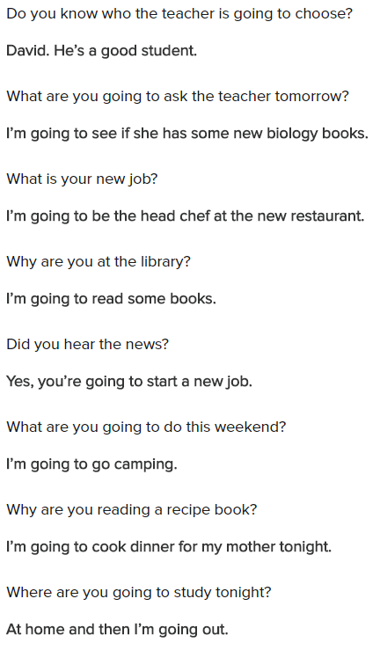

**Conversation**

What is dinner special today?

I am going to make tomato soup today.

We don’t have any tomato

Yes, that’s why I’m going to go shopping.

When are you going to go shopping?

I’m going to go now

Who’s going to watch the kitchen?

The temp cook is going be in the kitchen.

Oh, Sofi. Can you buy me a new shirt?

Sorry, I can’t. I’m not going to go to the department store.

**Exercise**

We are going to make pizza and pasta at the restaurant tonight.

I am going to start my new job tomorrow!

We went camping last weekend.

You’re on holiday next week. Are you going to go to the mountains?

My computer is broken, so I am going to buy a new one.

Harry is going to go on a trip tonight.

My teacher is angry. I think she is going to give us extra homework.

I am not going to eat all of my lunch because I am not hungry.

24.2.2

**Go to the dinning room, please.** I have a _… As you _ know, we need a head chef

Because she fires Dinnale

I choose a person who is a great chef, and have a _ for cooking. The head chef is someone who con teach the other employee what to do in the restaurant kitchen

You are a great chef and you love food

And I taught the temp cook

The new head chef is going to make a new menu and be going to _ that menu every night to all customers. Lady and the gentleman, the new head chef is _

He is going to be a head chef

Sorry Sofi

_ was the owner of dinning _, a great Italian restaurant. He sold his restaurant to the company, that is going to open thousands _, around America. Don’t you say anything _?

Thank you for hiring me, I want to work with you to make this is a great restaurant. I’m going the kitchen now

He’s great. Now because _ is a head chef, Sofi is his _ cook. Diego is still waiter

What’s about us?

You’re fire, you get the things to go

You are firing them? I just taught them how to work in the kitchen. You don’t need them because I have to do that work

That’s right. You have to work, Sofi. _ tell you how to do

Hello sir, nice to meet you

My name _. You are Sofi?

Yes, that’s me, sir, _

Nice to meet you, I want to work together just fine. I good feeling

Excuse me, what is on this?

These are supply for tonight to dinner

But we didn’t plan the menu

**Pass me the spoon.** Is it beef soup?

Yes

We are not going to serve this soup tonight or ever

Why not?

**Take this!**

_ spaghetti and meat sauce, but this is a French restaurant

It was a French restaurant, it was a dish make me famous. I work on new recipe per year. Don’t forget the pizza

I work on my recipe per year, customers like them

This is my restaurant now, I’m a head chef and I design a menu. Do you know how to cook meet sauce

Yes, I know how to cook meet sauce

I work to the supply, everything you need it there

Can tomato? We use fresh tomato

There are from Italy

OK

**Now, put that soup away**

Where?

**Put it in the fridge or throw down**

Move it out?

Yes. **Make the meat sauce and then dough for the pizza**. Do you know how to make pizza dough?

I think so

Good. You need to start next soon

Yes, of course

This is work

Sofi thinks she is going to be the head chef because she can cook and teach.

Sofi is not happy because she wanted to be the head chef.

Why does Renzo tell Sofi what to do?

-> he is her boss now

Why does Renzo take away the soup?

-> The restaurant will not sell the soup

Let me see the computer

Put this away in the closet

Pass me the milk

Please don’t do that

Go to the kitchen.

**Skill practice**

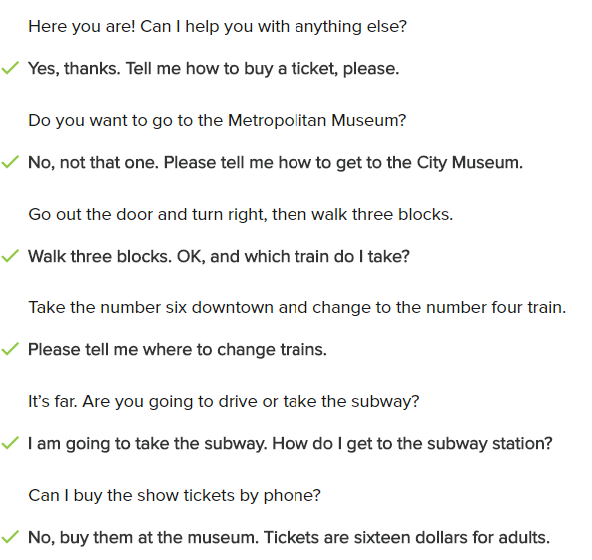

**Conversation**

I don’t have to work to day, where can I go?

The weather is nice. Go to the park!

What can I going to do in the park?

Go for a walk, or ride the bicycle

And how do I get there?

If you don’t want to walk there, take the the bus.

Which bus do I get turn?

Walk to Green Street and get on the bus downtown.

Where do I get off?

Get off the bus at Park Street. There’s a lot to do near there.

What good to do in Park Street?

Eat dinner in that great new restaurant!

**Exercise**

Customer: Please give me two train tickets .

Employee: $10, please.

Can I get you something?

-> Pass the salt, please

Please give me two train tickets.

-> $10, please.

Take the bus uptown and walk through the park

It’s cold. What do I need to wear?

-> Put on some gloves gloves: găng tay

How much is a bus ticket?

-> I think it’s $3

What am I going to cook for tonight's dinner?

-> Make spaghetti

Walk straight on Pine Street for ten minutes

Can I use my camera here?

-> No. Do not take pictures in the museum

**24.2.3**

This month concert in the park.

It’s happy to present Annie actor and four women band

**This is Annie’s first show in seven years**

The famous good job player, _ with Annie and her band .**The concert is Saturday**

**June 10 at Palm city Park**

**The park opens at one, and the show starts at three**

**Bring a blanket and have a picnic lunch before the concert**

No glass please, **children are welcome!**

**Tickets are only $25 for adults and $15 for children under twelve**

Tickets go on sell this Friday at 10 A.M

**You can get your ticket at PalmCityConcerts.com** or call to take ticket office at 423 555 1876

**Tickets are going to sell cloud**. So don’t wait until the date of the show

And don’t miss this awesome concert.

**It’s going to be a great time for the whole family**

Keep listening to a radio, next week.

This is announcement for July concert in the park.

It’s going to be a great one

What is this announcement about?

-> A music show

The show is going to be in a park

People can have a picnic before the show

People can buy their tickets on the Internet or by phone

The show is for the whole family

We have a very important announcement today!

He has to have a passion for signing

The band is going to play every day this week

His last day of work is next Monday

First, welcome to our show!

**Practice**

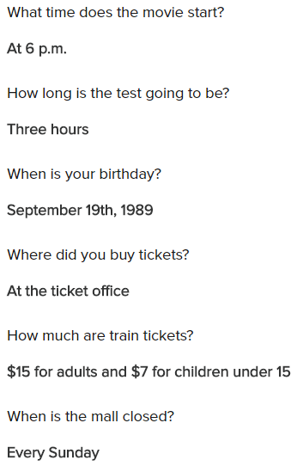

**Skills practice**

When was Annie’s last show?

-> Seven years ago

When is the show?

-> On Saturday, July 10

What time does the show start?

-> At three o’clock

How much are tickets for adults?

-> $25

How much are tickets for children?

-> $15

When do tickets go on sale?

-> This Friday at 10 a.m.

Why do you need to buy the tickets now?

-> There aren’t going to be any tickets left

**Conversation**

Good afternoon! How can I help you?

Hi, I’d like to buy a ticket please

Sure, where would you like to go?

I need to go downtown. How much is it?

A ticket downtown cost $8

I also want to buy ticket back. How much is the total?

It’s $8 it way. Oh but I feel buy both ticket you can get a deal

Great. How much for both tickets?

That’s going to be $12 for both ticket

Ok. Do you have change for 20?

Yes, I do, here is your change. Is there anything outside I can do for you?

What time does the train leave?

The train leave at 2p.m

OK. I have one more question. Which train do I get on ?

I can get on train number 5 to go downtown. Here are your ticket?

Thank you

**Exercise**

What is the announcement about?

Excuse me, what time does the bus leave?

-> In 15 minutes, sir.

What is the announcement about?

-> A new flight time

Which flight is late?

-> Flight 56A

Flight 56A is going to leave at eight o’clock.

Here’s $50

-> Thank you. This is your change

Where is the train going to go?

-> Uptown

When is the train going to leave?

-> In ten minutes

How long does it take to get uptown?

-> One hour and fifteen minutes

**Lesson Exercises**

Our boss is going to fire all of us

We’re going to have lunch at that new cafe

All of the employees are going to say late today

I am going to buy a new shirt for the party

We’re going to have a beach holiday in January

Excuse me, sir. Please go to the dining room and sit down

Will, don’t put that plate on the table

-> Okay. Where can I put it?

Take off your coat-it’s hot in here

Please call me when you get home

-> Sure! I can call you

Sofi doesn’t have her call phone with her

-> She always forgets it at home

Please don’t watch TV so late at night

Go into the kitchen and get me a big bowl

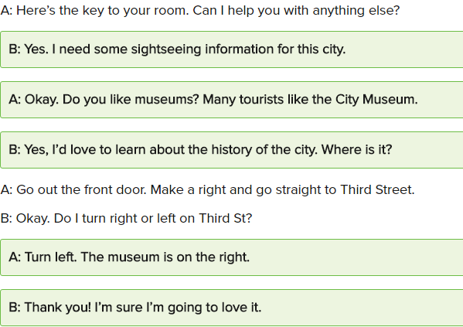

When is the library open?

-> On weekdays, from Monday to Friday

Announcement: The train to New York is not on time. It now leaves at 4:25

Julie: What was that announcement?

Tim: It says our train to New York is going to be late.

Clare: When are they going to buy that house?

Tom: I think they’re going to buy it next month.

How long is the movie?

-> Two hours

**1/10**

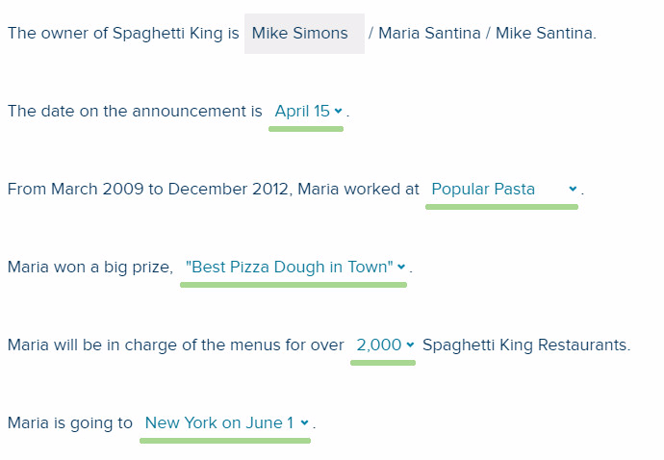

**2/10**

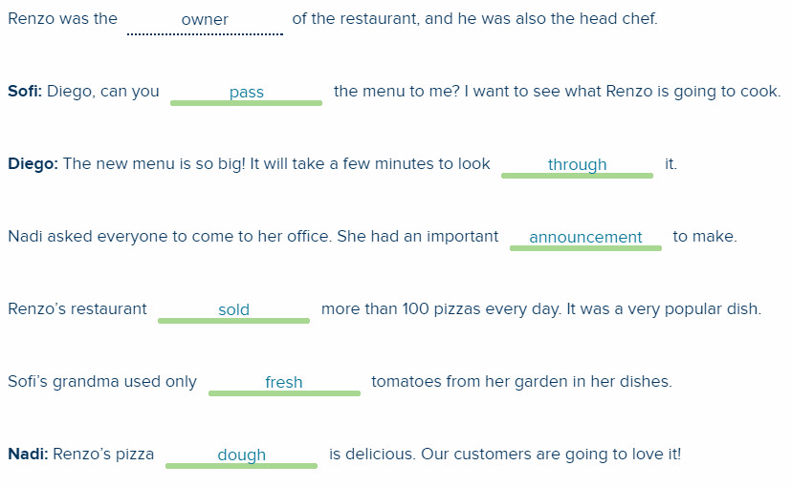

**3/10**

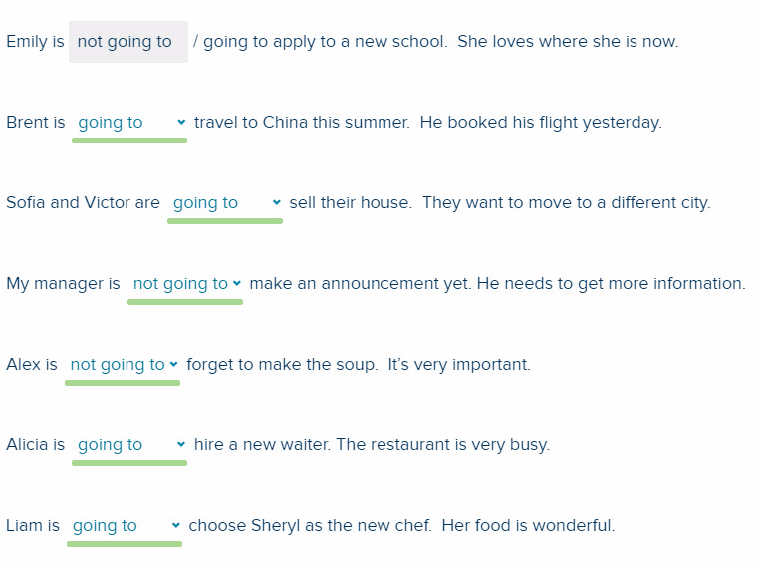

**4/10**

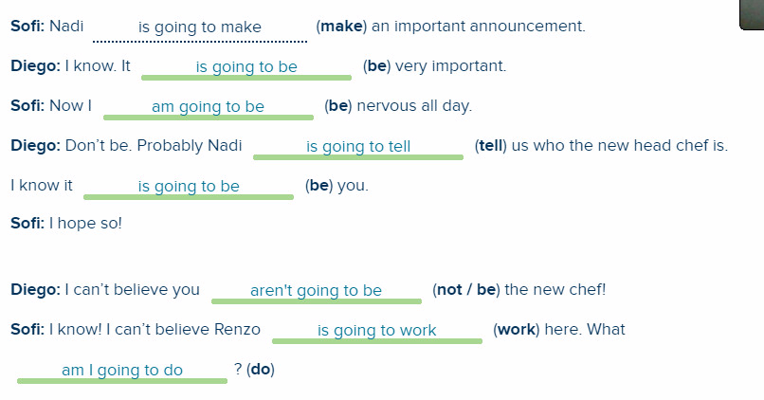

**5/5**

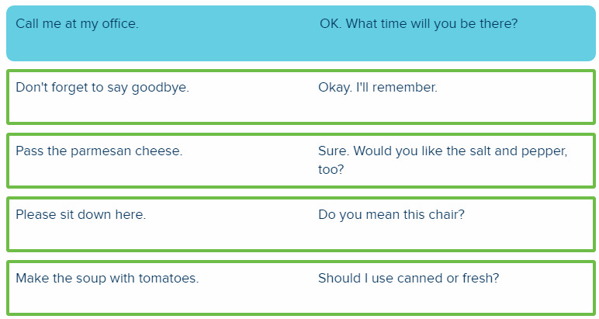

**6/10**

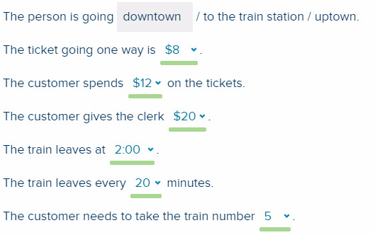

**7/10**

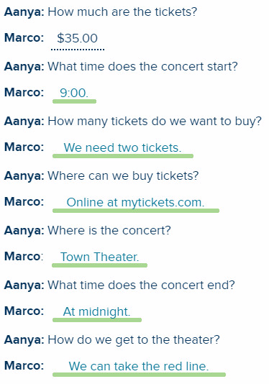

**8/10**

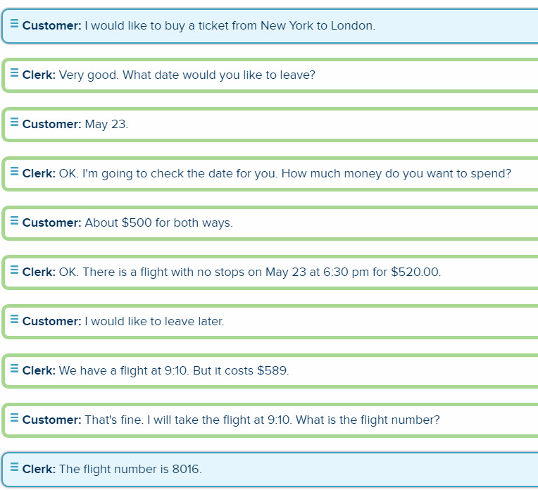

**9/10**

Sofi: What time does the train to Sea Beach leave?

Diego: The train to Sea Beach leaves at 2:20.

Sofi: How much is a ticket to come back?

Diego: A ticket to come back costs $11.75.

Marco: What are we going to do today?

Aanya: Today, we are going to work on a new design.

Marco: What are we going to do tomorrow?

Aanya: Tomorrow, we are going to go to the beach.

Sofi: What do you want me to do now?

Renzo: Please dice the tomatoes for the sauce.

**10/10**

John: Hello. I would like to book a trip from Shanghai to San Francisco.

Travel Agent: Sure. When would you like to travel?

John: I want to leave September 13 and return on October 2.

Travel Agent: Ok. I am going to look that up. We have two flights a day. One leaves at 12:10 pm and one leaves at 1:20 pm.

John: What are the prices?

Travel Agent: Flight 685 leaves at 12:10. It costs $1,412.00 round trip.

John: That’s expensive. What about the other flight?

Travel Agent: That’s flight 964 and it’s $1,550.

John: Thank you. I am going to think about it.